Project Design Phase-II
Data Flow Diagram & User Stories
Date | 01 July 2026
Team ID
Project Name | Nutrition Assistant Using MERN stack
Maximum Marks | 4 Marks
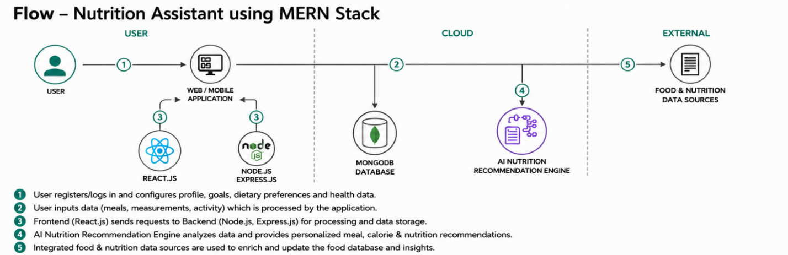
Data Flow Diagrams: A Data Flow Diagram (DFD) is a traditional visual representation of the information flows within a system. A neat and clear DFD can depict the right amount of the system requirement graphically. It shows how data enters and leaves the system, what changes the information, and where data is stored.

Example: (Simplified)
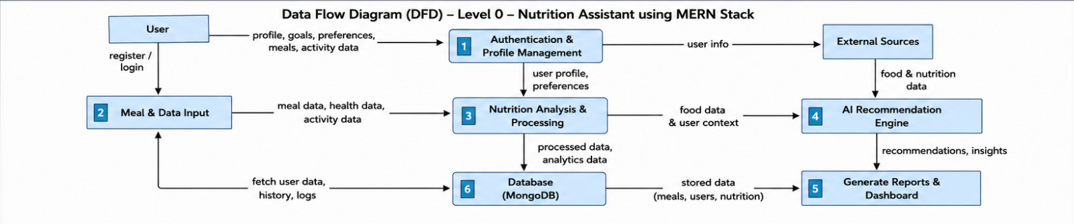

User Stories
User Type | Functional Requiremen  t  (Epic) | User  Story  Numbe  r | User Story / Task | Acceptance criteria | Priorit y | Releas  e
Customer  (Public User) | Dashboard Access | USN-1 | As a user, I can view the interactive dashboard without logging in. | Dashboard loads successfully in browser | High | Sprint1
Customer  (Public User) | Data Filtering | USN-2 | As a user, I can filter agricultura l data by State, Crop, and  Season. | Charts update dynamically based on  filters | High | Sprint1
Customer | Geographic | USN-3 | As a user, I | Tooltip | High | Sprint-
Use the below template to list all the user stories for the product.
(Public User) | View |  | can interact with the India map to see state-wise  production  . | shows exact production for the  hovered state |  | 1
Administrato  r | Data Update | USN-4 | As an admin, I can update the static dataset via Tableau Public. | New data reflects on the web app automaticall y | Medium | Sprint2

